- Write HTML code to set background image on a page.
<!DOCTYPE html>
<html>
<head>
<title>Background Image Example</title>
<style>
body {
background-image: url("./images_folder/image.png");
background-size: cover;
background-repeat: no-repeat;
/* background-position: center; */
color: purple;
text-align: center;
}
</style>
</head>
<body>
<h1>Background Image Example</h1>
<p>This page has a background image of pashupathi temple of Nepal.</p>
</body>
</html>

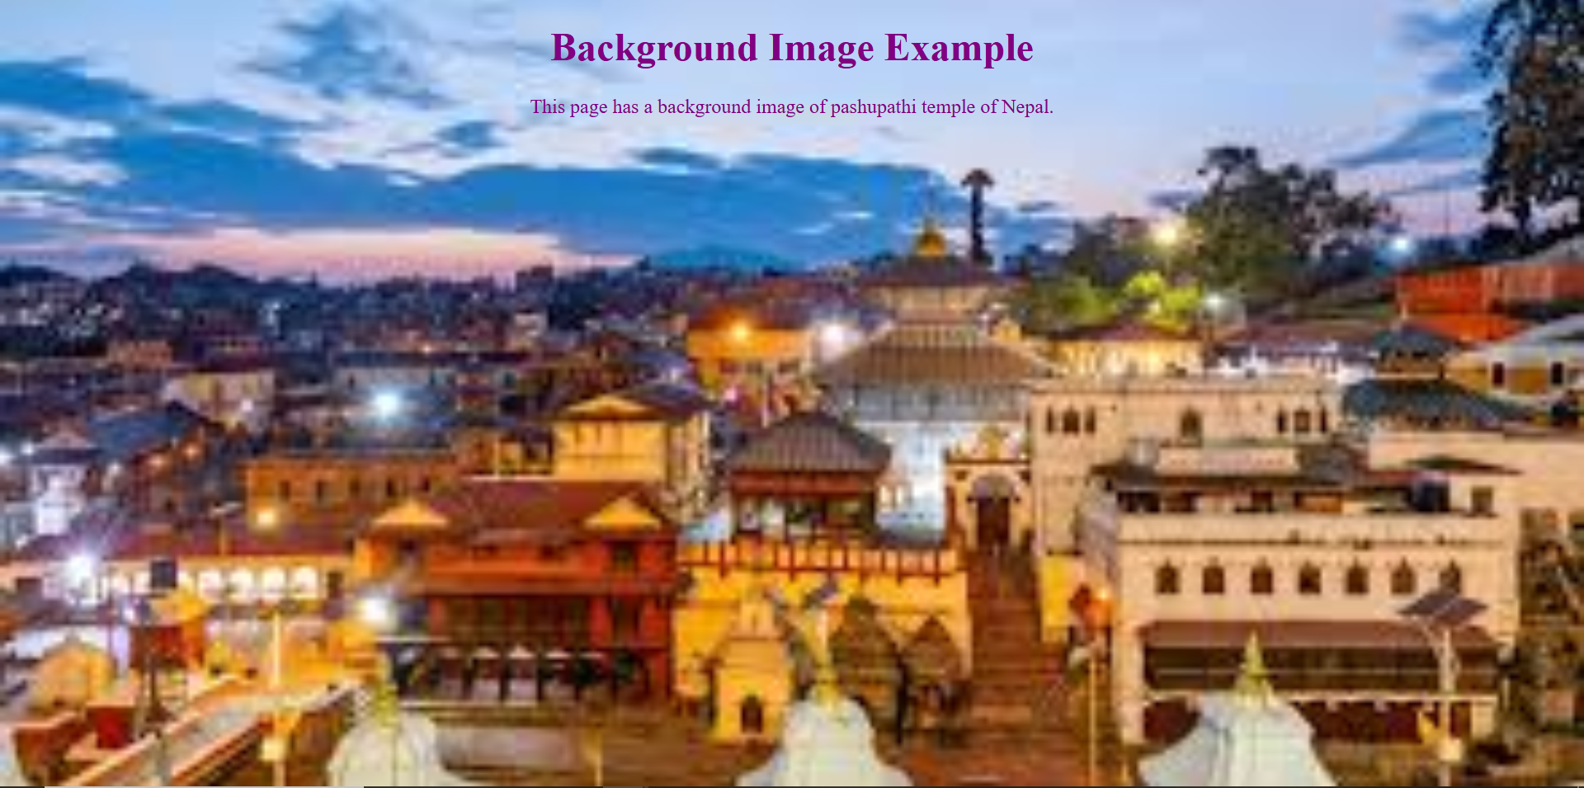
- Write HTML code to set an image in any particular position on a page.
<!DOCTYPE html>
<html lang="en">
<head>
<meta charset="UTF-8" />
<meta name="viewport" content="width=device-width, initial-scale=1.0" />
<title>image at a particular position</title>
</head>
<body>
<center>
<h1>Image at a particular position</h1>
<p>Image of pashupathi temple.</p>
<img
src="./images_folder/image.png"
alt="Image of pashupathi temple"
height="200"
width="300"
/>
</center>
</body>
</html>

Write HTML code to prepare a document using different heading format. Eg.
(H1 to H6).

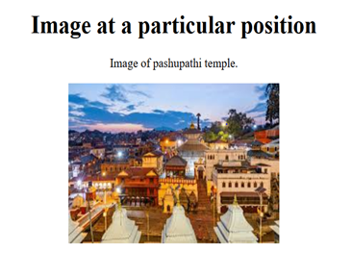
- Write HTML code to prepare a document using different heading format. Eg. (H1 to H6).
<!DOCTYPE html>
<html lang="en">
<head>
<meta charset="UTF-8" />
<meta name="viewport" content="width=device-width, initial-scale=1.0" />
<title>Heading format</title>
</head>
<body>
<center>
<h1>About Myself</h1>
<h2>My Name</h2>
<p>My name is Bikram Gyawali</p>
<h3>My Age</h3>
<p>I am <u>19</u> year old</p>
<h3>My Study</h3>
<p>I am currently studing <i>BCA 3rd sem at SMC</i>.</p>
<h4>Address</h4>
<p>I am from <b>Butwal</b></p>
</center>
</body>
</html>
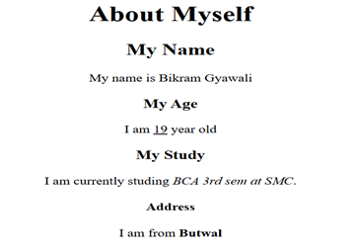
- How to set Bullet and Numbering.
<!-- Question nbr 4 first question -->
<!DOCTYPE html>
<html lang="en">
<head>
<meta charset="UTF-8" />
<meta name="viewport" content="width=device-width, initial-scale=1.0" />
<title>Bullets</title>
</head>
<body>
<ul type="square">
<li>
Hardware
<ul type="circle">
<li>Keyboard</li>
<li>Mouse</li>
<li>HDD</li>
</ul>
</li>
<li>
Software
<ul type="circle">
<li>System Software</li>
<li>Application Software</li>
<li>Tailored Software</li>
</ul>
</li>
</ul>
</body>
</html>

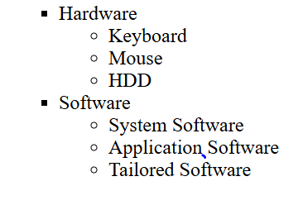
- Another list

<!DOCTYPE html>
<html lang="en">
<head>
<meta charset="UTF-8" />
<meta name="viewport" content="width=device-width, initial-scale=1.0" />
<title>4 second Question</title>
</head>
<body>
<ol typpe="1">
<li>
Progamming
<ol type="I">
<li>
Basic Language
<ol type="a">
<li>QBasic</li>
<li>OOPs</li>
</ol>
</li>
<li>
Advanced Language
<ol type="a">
<li>ASP .Net</li>
<li>Php</li>
<li>Java</li>
</ol>
</li>
</ol>
</li>
<li>
Desiging

<ol type="I">
<li>
Graphics Desiging
<ol type="a">
<li>Photoshop</li>
<li>InDesign</li>
</ol>
</li>
<li>
web Page Desiging
<ol type="a">
<li>HTML</li>
<li>CSS</li>
<li>JavaScript</li>
</ol>
</li>
</ol>
</li>
</ol>
</body>
</html>

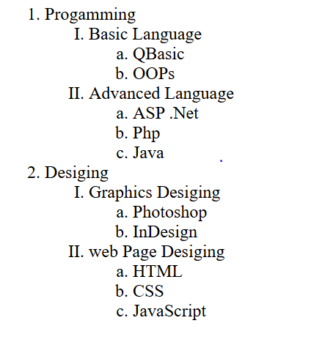

- Write a code to generate the following table.

<!DOCTYPE html>
<html lang="en">
<head>
<meta charset="UTF-8" />
<meta name="viewport" content="width=device-width, initial-scale=1.0" />
<title>Table</title>
</head>
<body>
<table cellspacing="0" cellpadding="0" border="1">
<tr colspan="7">
<th>BCA 3<sup>rd</sup> Semester Routine</th>
</tr>
<tr rowspan="2">
<th>Day/Time</th>
<th>7am-8am</th>
<th>8am-9am</th>
<th>9am-9:30am</th>
<th>9:30am-10:30am</th>
<th>10:30am-11:30am</th>
<th>11:30am-12:30pm</th>
</tr>
<tr>
<td>Sunday</td>
<td>Web Tech</td>
<td>SAD</td>
<td rowspan="6">Break</td>
<td>DSA</td>
<td>Statics</td>
<td>Java</td>
</tr>
<tr>
<td>Monday</td>
<td>DSA</td>
<td>Statics</td>
<td>Java</td>
<td>Web Tech</td>
<td>SAD</td>
</tr>
<tr>
<td>Tuesday</td>
<td>Java</td>
<td>Web Tech</td>
<td>SAD</td>
<td>Statics</td>
<td>DSA</td>
</tr>
<tr>
<td>Wednesday</td>
<td>Java</td>
<td>Web Tech</td>
<td>Statics</td>
<td>DSA</td>
<td>SAD</td>
</tr>
<tr>
<td>Tuesday</td>
<td>Web Tech</td>
<td>Statics</td>
<td>DSA</td>
<td>Java</td>
<td>SAD</td>
</tr>
<tr>
<td>Friday</td>
<td>Java</td>
<td>SAD</td>
<td>Web Tech</td>
<td>Statics</td>
<td>DSA</td>
</tr>
<tr>
<td>Saturday</td>
<td colspan="6">Holiday</td>
</tr>
</table>
</body>
</html>

